**Health and Safety Performance Report 2017-18**

1. **Purpose of Report**

1.1 This report has been prepared by Two Rivers Housing’s Safety, Health and Environmental Manager with a purpose of giving all stakeholders an overview of health and safety performance during the period of 01st April 2017 to 31st March 2018.

1. **General Health, Safety and Wellbeing Management Performance Scores**

2.1 **Key performance indicators** – The key performance indicators measured are:

* Risk assessment
* Inspection outcomes
* Audits
* Training
* Action plan
* Policy
* Staff handbook
* Equipment management

The target has now been raised from 85% to a target of 92%.

Graph 1 below shows the overall percentage scores taken from our safety management system for health, safety and wellbeing management during the period of Apr 2015 to March 2018; each line represents a financial year.

Table 1 shows the monthly percentage scores for the 2017/18 finacial year.

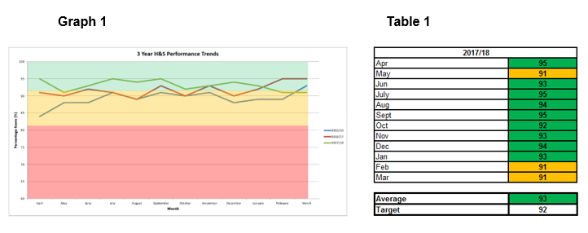

1. **Accident Management**

3.1 The graph below shows the overall accident statistics across the TRH group during the period of April 2015 to March 2018. These are broken down into their respective financial years.

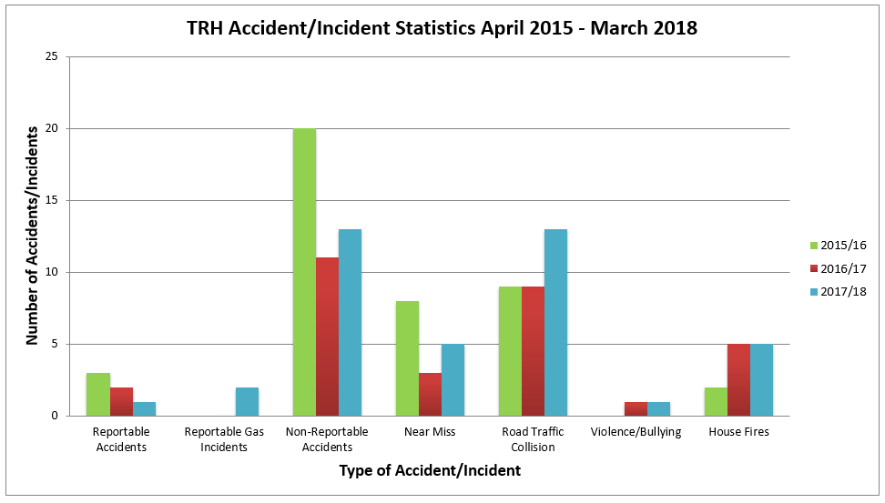

1. **Gas Servicing**

4.1 As at 31st March 2018, we have achieved 99.99% month-end compliance. The 100% target has been achieved 7 out of 12 months during 2017-18, we have achieved 99.7% and above for the other 5 months. This demonstrates a consistently high level of compliance to gas servicing.

RSM completed a gas service audit in October 2017. The external audit concluded that *“the Board can take substantial assurance that the controls upon which the organisation relies to manage the identified risk(s) are suitably designed, consistently applied and operating effectively.”*

1. **Solid Fuel Servicing**

5.1During 2017-18, we achieved an average month-end compliance for this area of 98.2%. Unfortunately, performance was at its lowest on 31st March which was reported to be 90.43%. The current level of performance has been formally addressed with the Contractor and assurance received that this will receive PH Jones’ utmost attention. PH Jones have been instructed to restore compliance by 30th April 2018 – target 99.5%.

1. **Legionella Management**

6.1Recent water samples of communal centres show no areas of concern. Planned Maintenance are continuing to review mandatory testing of rainwater harvesting systems in collaboration with Integrated Water Services. Two Rivers Housing are continuing to act in a responsive manner where issues arise until an economical and justified servicing and maintenance regime is achieved.

1. **Asbestos management**

7.1Surveys for both planned maintenance, responsive and void works are carried out ahead of the programme and made available to either the contractor or PropertyPlus to allow for safe planning. If there is a requirement to remove any asbestos then this is arranged through TRH and completed prior to the commencement of work. Asbestos condition inspections of the communal areas are carried out annually, we have completed all 62 of the communal re-inspections. The latest re-inspection surveys confirmed there has been no condition change; therefore, no action is required. Asbestos condition inspections for individual dwellings of the housing stock are carried out during stock condition surveys or at void stage. To date there have been no areas of concern.

1. **Fire management**
   1. **Fire doors** –The fire door inspection programme has currently fallen behind by one month with 70% completed so far, we aim to complete the remaining 30% by end of May.
   2. **Fire risk assessments (FRA’s)** – Our current fire risk assessments are now coming up to their 4-year anniversary and to comply with the Regulatory Reform (Fire Safety) Order 2005 we are required to have all fire risk assessments rewritten. We have recently procured a new fire safety consultancy to undertake this work which will be smoothed out over the 2018/19 financial year.
   3. **Fire asset servicing (alarms, extinguishers etc)** – Two Rivers Housing has completed the procurement of the Fire Servicing and Maintenance Contract. A&E Fire and Security have been appointed to undertake the 3-year contract with provision for a two-year extension subject to performance. A&E Fire & Security commenced the contract on 14th March and ended the financial year with 100% compliance.
   4. **Fire alarm remote monitoring** – There are currently 31 addressable fire alarm systems within the housing stock. The Planned Maintenance Team are currently reviewing the process should an alarm be activated, there are two options open to us which are:
2. Option 1 – Remote monitoring by a 3rd party call centre which will notify Fire and Rescue
3. Option 2 – When the alarm sounds it will notify a chosen internal contact to respond

We are currently reviewing each system to ensure that they are compatible for remote monitoring and, once completed, a programme will be developed and the works completed.

1. **Electrical installation condition reports**
   1. 286 properties were due an EICR within the 2017/18 financial year. We have successfully completed 246 properties with the remaining 40 presenting themselves as no access. These 40 units are being pursued via our no access procedure and are either at stage 1 or 2 within the procedure meaning further attempts will be made to gain access before the properties are passed back to housing management for action. There is no legislative requirement for TRH to undertake testing on a 5-yearly basis, although it is recognised within the industry as best practice.
2. **Royal Society for the Prevention of Accident (RoSPA) 2018 Awards**

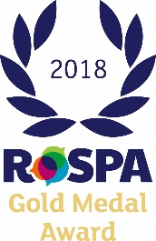

10.1 Two Rivers Housing participates in the annual RoSPA Awards; the process requires us to respond to 19 units which require detailed responses supported with 8 pieces of evidence per unit.

RoSPA’s adjudication panel is made-up of health and safety professionals who scrutinise each unit response.

The adjudication panel have awarded Two Rivers Housing with a Gold standard for the 5th consecutive year resulting in Two Rivers Housing receiving the Gold Medal Award.

This process confirms that Two Rivers Housing is committed to the safety of its staff and tenants and that we have robust systems in place to help us achieve this.

1. **Tenant Health and Safety Handbook**

11.1 A comprehensive ‘Safety in the Home’ handbook has been developed and made available to our tenants via TRH’s website. The Safety, Health and Environmental Manager is currently exploring the possibility of delivering centralised workshops to tenants who don’t have access to the internet.

1. **Reporting**

12.1 Comprehensive year 2017/18 year end health and safety report has been submitted to the Board for comment.

1. **Summary**

13.1 The general management of health, safety and wellbeing has improved from that of previous years and meeting the requirements of legislation.